Back to School Event Success 2017
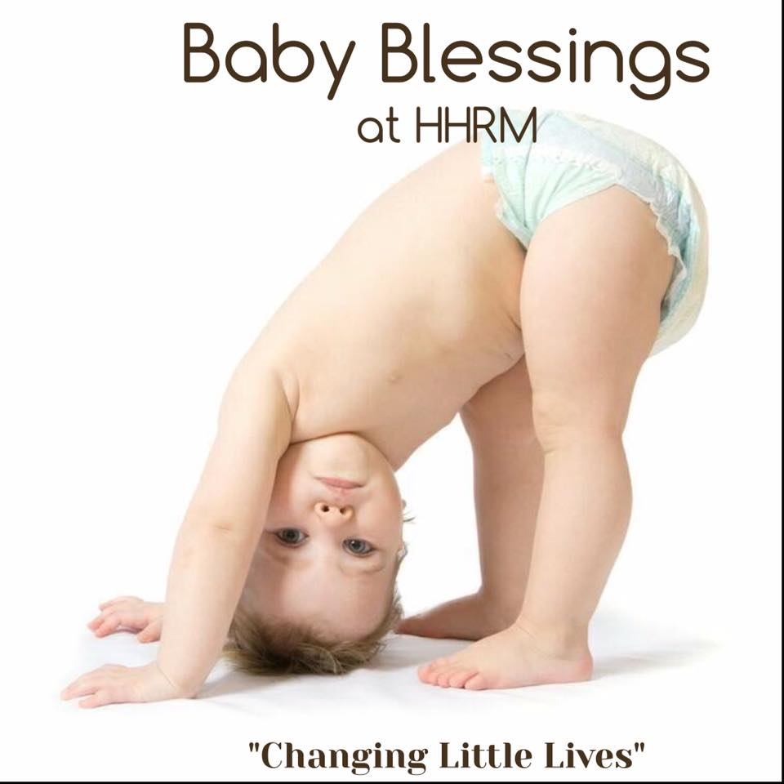

HHRM NEWS

P
Founded by Revs. Jim & Rose Marie Gaines & Mrs. Florence E. Meringola 1965
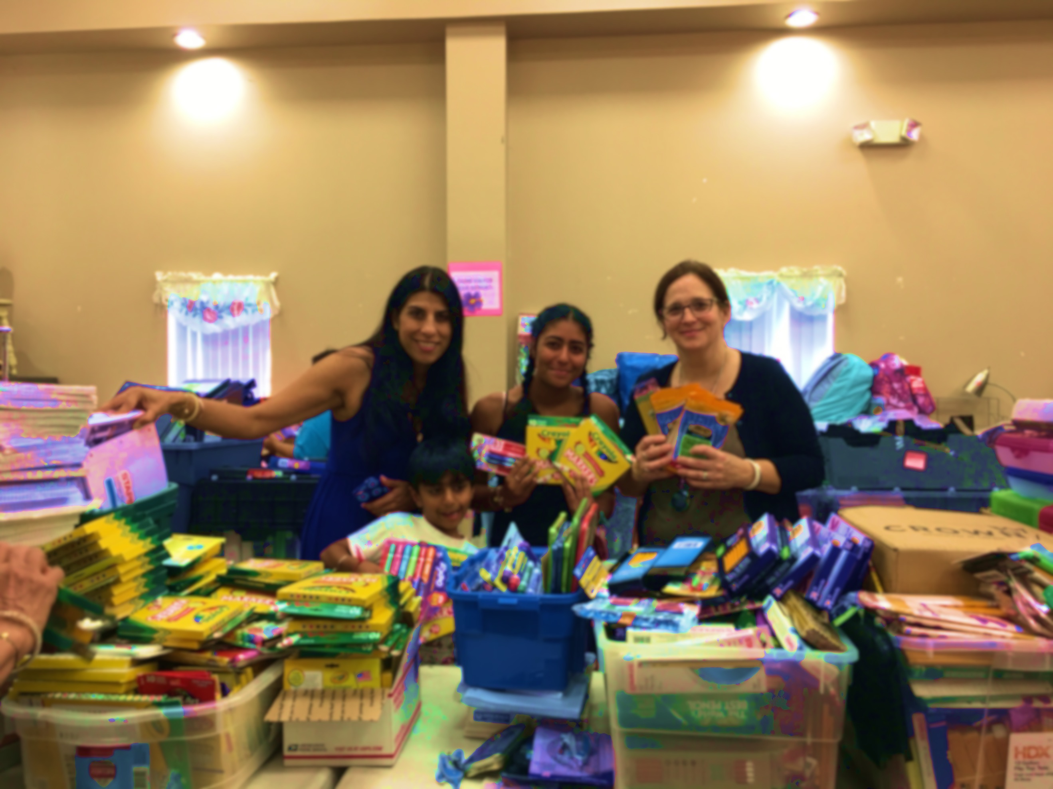
Baby Blessings at HHRM
Changing Little Lives"
Beginning September 20th, once a month on the third Wednesday of the month Moms from Huntington Township can come and receive baby items as available from our "baby pantry". It is our desire to help meet diaper and baby supply needs in our community.
A light lunch for moms desiring to attend will be served at 12:30pm and an inspirational devotional will be shared by one of our beautiful mission moms.
Donations of all sizes of diapers and baby wipes are needed and appreciated. $20.00 will buy almost 200 diapers on Amazon.com.
We are planning to give each mom who attends a week’s supply of diapers and other items.

Our annual Back to School new backpack and school supply distribution was one of our best ever! Over 350 local children were blessed with beautiful, new backpacks filled with school supplies for their specific grades.
The young lady, Maleeha Vij, pictured with her mom and brother wanted to make a difference for others this summer and she did by collecting the school supplies you see pictured here. There were enough to fill over 60 backpacks with the needed supplies and some extra items. What an amazing job!

Many others helped to fill our backpacks this year. St. Peter’s Lutheran Church of Huntington Station did an incredible job with their supply drive this year. We were so happy to have the Huntington Crescent Club make a generous donation of new supplies and backpacks to help our efforts this year.

Kind people who saw our sign or heard about our event online came and brought small and large donations of school supplies and with funds that we raised we were able to go out and purchase additional needed items.
Many different people came together to help pack the backpacks and to organize them for distribution. Everyone working together made a big job go very smoothly and seamlessly.

The day of the distribution was a really beautiful day. God blessed us with beautiful weather, Chick Fil A, new toys and snow cones. Does summer get any better than that for kids? Chick Fil A of Commack generously donated our lunch, TTPM (Toys, Tots, Pets & More) of Manhattan donated 40 new toys which were given to the children via a free raffle that was so much fun. You can watch a video of our event on Youtube HHRM’s Back to School Event 2017. We are so happy that we were able to give these children a wonderful start to their school year. Thank you!
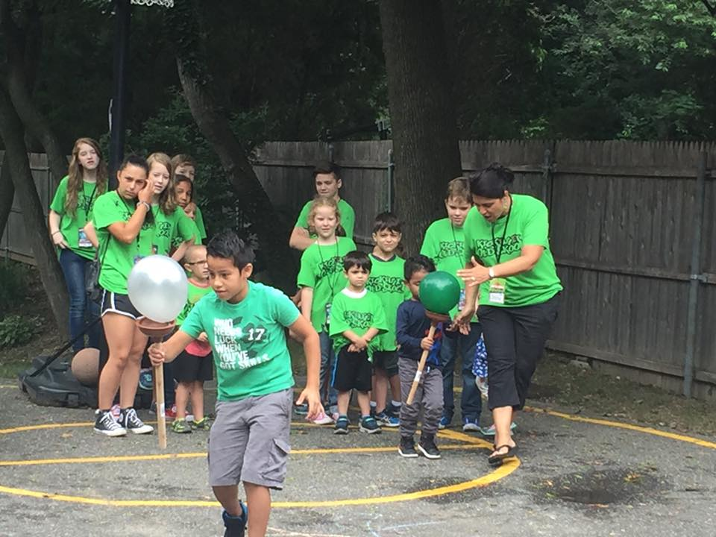
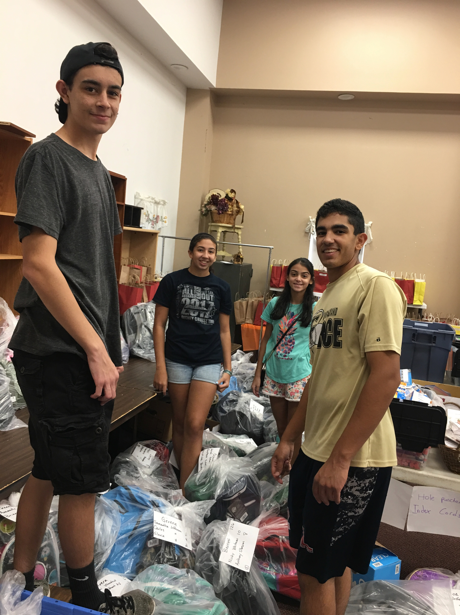
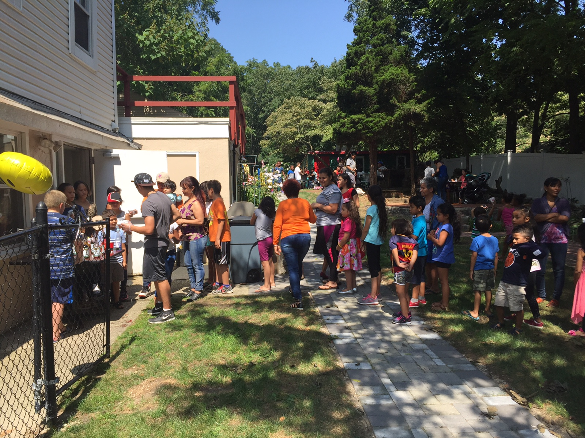

September 5, 2017
Dear Family, Friends and Mission Partners,
Is it really possible that we are in the first days of September already? Where did summer go?
I was wondering what the first summer at HHRM without my mom would be like, Well, it was very busy and I guess that’s a good thing. I remembered last summer and all the work that we accomplished together. I miss her but I continue on as she and dad would want and expect and as God has truly placed a desire in my heart to do. When Mom was in the hospital she said, “Don’t waste your energy crying. You have a lot of work ahead.” She knew. The work at HHRM fills my heart with joy just knowing that we are sharing the good news of God’s love with those who He cares for so greatly while helping with other important needs at the same time.
Our food pantry was open from 1-4pm Tuesday through Friday and many people and families came each week to receive a parcel of food to help them through the month. Our Thursday community lunches were often very busy with more moms and children this summer than ever before. Everyone was happy to have a delicious, healthy meal. Children enjoyed playing on the playground, eating popsicles and just being kids. The clothing racks filled up and emptied out each day. Thanks for helping us fill them!
My heart has always been extra tender towards moms and their babies. People who struggle economically are often unable to afford baby needs like diapers and wipes. Some people actually reuse their diapers or babies go unchanged to make the diapers available last longer. Funds from SNAP or EBT are not permitted to be used for diapers. “Diaper need” is a viable need and we want to help these babies to have what they need to be comfortable, happy and healthy.
Beginning September 20, 2017 in addition to our regular operations, we will have “Baby Blessings” available on the third Wednesday of each month. This is the kick off of our new “diaper program”. We have always provided layettes, diapers and baby items but we are organizing it into a more formal program. Moms with infants will be able to come once a month for diapers and baby items as we have them available. We will also have a light lunch and inspirational devotional available to them that afternoon. We are very excited about this new effort and welcome donations of diapers, baby items and funds to help with diapers and lunch.
Our kitchen fire system has been updated and looks great. Thanks to those who helped with that need. We are ready for lots of safe cooking as we come into the cooler months.
Please consider attending our Founder’s Tea, Saturday, October 21, 2017 at the Huntington Assembly of God. Tickets are $25 and include a delicious tea luncheon with finger sandwiches from the exquisite Culinary Studio of Huntington, petite desserts, hot tea, coffee and more.
It will be a special time honoring my mom’s memory and also recognizing several of our wonderful volunteers, Mrs. Debbie Gerken, Mrs. Robin Corley, Ms. Laraine Schippa and Mrs. Jane Maresco of St. Peter’s Lutheran Church’s Feed the Hungry Program. Proceeds will help to support our many holiday programs at HHRM including Thanksgiving food baskets and our 53rd Annual Christmas Party for Children 12/16. Why not come and bring a friend?
With Many Thanks for Your Prayers & Support,
Kim
Rev. Kimberly Gaines-Gambino, President

A gift of
With $20 we can purchase almost 200 diapers, feed 15 people a healthy lunch or help to provide necessary supplies and materials for our events.
Would you consider becoming a Monthly Mission Partner for the very busy months of October, November and December? In addition to our regular operations we will be providing 400 families at Thanksgiving with complete meal food baskets including a turkey, providing a beautiful Christmas party for 400 children (our 53rd Annual) hosting a “free of charge” Fall Family Fun Day with pumpkin painting and lunch and so much more.
You may send your gift or more or sign up for easy online recurring donations www.hhrm.org.
, 20 packs of baby wipes, or prepare lunch for 10 people.
Will you consider become a Monthly Missiake a monthly financial contribution of your choice to HHRM. Even $20 makes a big difference!
Simply write MMP in the memo section of your check or sign up for a recurring gift via our website online, www.hhrm.org.

Some Opportunities for Community Service at HHRM Include
- Wrapping toys (Nov. 10th)
- Happy Day Express
Call to Schedule 631-351-6996
- Hosting Food Drives
- Family Fall Fun Event (11/4)
- Baby Blessings Distrib. 9/30
- Organizing Clothing (daily)
- Boutique Set Up 9/30-10/3
- Thanksgiving Food Baskets

If you are interested in serving with us at HHRM, please email me at kimberlygambino@hhrm.org

It’s always wonderful to serve others together.

Feel free to call or text me at 631-678-8250 Tues-Saturday.

Your monthly gift of even $20 goes a long way at Helping Hand Rescue Mission.
Having Fun With Kids

Help Us To Make It Happen! Become a Monthly Mission Partner
In State Farm Insurance of Huntington Station, New York helps us each year with our Back To School drive. This year was the first year that my mom wasn’t here to pick up the proceeds of their collection personally. I was met at their office by a young woman with a big smile. She presented many boxes of new backpacks and supplies and 100 new hats, gloves and scarves that they had collected.
She said, “I miss your mom. We started doing this years ago to give back. When I was a young woman in need your mom helped me so much. She loved me, gave me hope and provided household items, food and clothing. This is our way of saying ‘thank you’ and helping others.”
I was reminded of a scripture that God put on my heart when my mom was in the hospital. “They rest from their labors and their works follow them.”
I love this story. Thanks Mom!

Touching Lives In Our Community
Packing Backpacks!
Exciting Dates & Events For September and October
Baby Blessings Diaper Pantry-September 20th 10:30am-1pm
Free Family Fall Clothing Distribution-10am-3pm
Annual Harvest Boutique Fundraiser-October 5, 6, 7 10am-4pm
Fall Founder’s Tea October 21, 2017 @ Huntington Assembly of God 12-3pm Please call 631-351-6996 for tickets or visit our website www.hhrm.org
If you wish to be removed from this mailing list please email me at kimberlygambino@hhrm.org

Helping Hand Rescue Mission Inc.
P.O. Box 325
225 Broadway
Huntington Station, N.Y. 11746
Non-Profit Organization
U.S. Postage
Paid
Hunt. Sta. N.Y.
Permit No. 82

Donec
interdum

Pellentesque:

